**Feature Selection** is the process where you automatically or manually **select** those **features** which contribute most to your prediction variable or output in which you are interested in. Having irrelevant **features** in your data can decrease the accuracy of the models and make your model learn based on irrelevant **features.**

# Fundamental Techniques of Feature Engineering for Machine Learning

<https://towardsdatascience.com/feature-engineering-for-machine-learning-3a5e293a5114#3abe>

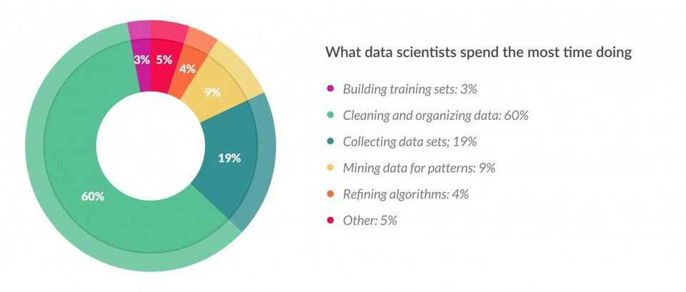

## List of Techniques

Imputation

Handling Outliers

Binning

Log Transformation

One-Hot Encoding

Grouping Operations

Feature Split

Scaling

Extracting Dates & Formatting

# Feature Engineering: The Secret Ingredient of Machine Learning

<https://www.vidora.com/ml-in-business/feature-engineering/>

# How to Choose a Feature Selection Method For Machine Learning

<https://machinelearningmastery.com/feature-selection-with-real-and-categorical-data/>

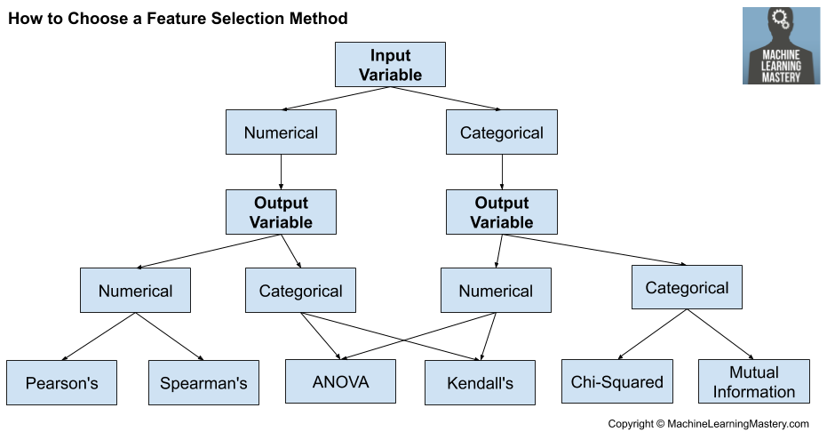

**Weight of Evidence (WOE) and Information Value (IV) Explained**

<https://www.listendata.com/2015/03/weight-of-evidence-woe-and-information.html>

<https://www.kaggle.com/davidbnn92/weight-of-evidence-encoding>

# Feature Engineering

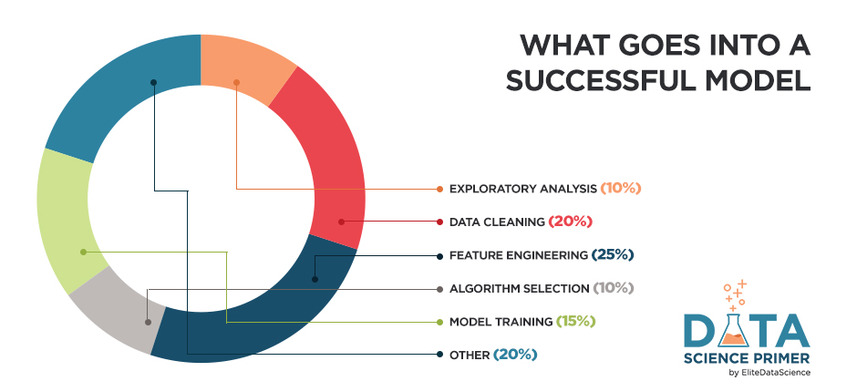

<https://elitedatascience.com/feature-engineering>

You can isolate and highlight key information, which helps your algorithms "focus" on what’s important.

Scikit-learn

<https://scikit-learn.org/stable/modules/feature_selection.html>

* [1.13. Feature selection](https://scikit-learn.org/stable/modules/feature_selection.html)
  + [1.13.1. Removing features with low variance](https://scikit-learn.org/stable/modules/feature_selection.html#removing-features-with-low-variance)
  + [1.13.2. Univariate feature selection](https://scikit-learn.org/stable/modules/feature_selection.html#univariate-feature-selection)
  + [1.13.3. Recursive feature elimination](https://scikit-learn.org/stable/modules/feature_selection.html#recursive-feature-elimination)
  + [1.13.4. Feature selection using SelectFromModel](https://scikit-learn.org/stable/modules/feature_selection.html#feature-selection-using-selectfrommodel)
  + [1.13.5. Feature selection as part of a pipeline](https://scikit-learn.org/stable/modules/feature_selection.html#feature-selection-as-part-of-a-pipeline)